Econ 351 Cheat Sheet for exam 1

Chapter 2

Derivative Rules
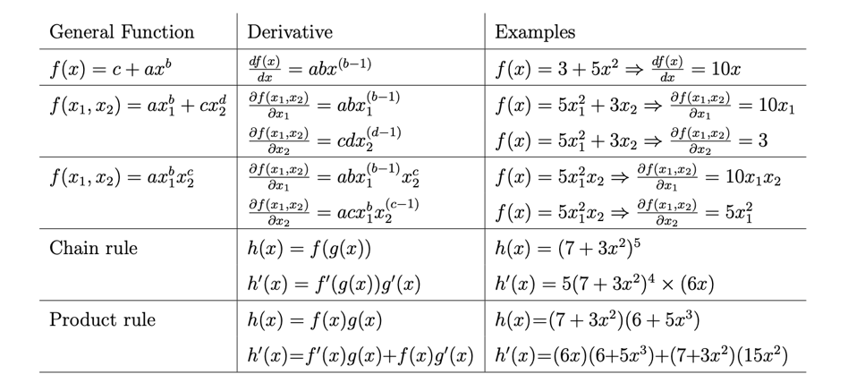

Price Elasticity of Supply
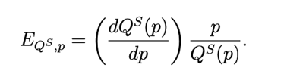
Price Elasticity of Demand
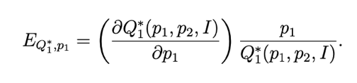
Or E= percent change in Q / percent change in P
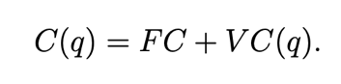
Average Cost, Average Fixed Cost, Average Marginal Cost, Marginal Cost
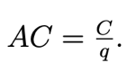 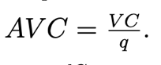 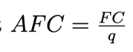, 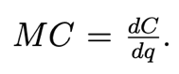
Revenue=pQ

Profit
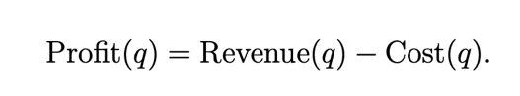
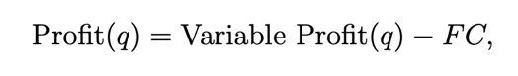
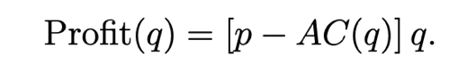

Chapter 6
Lerner Index of Market Power


